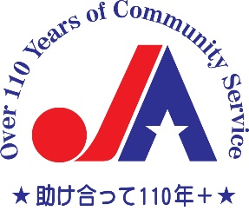
2023 JAA - Honjo Scholarship Awards

Through generous funding from the Honjo Foundation, JAA is looking for qualified candidates for its 2023 JAA - HONJO Scholarship. This is open to students who will be enrolled in a full-time course of graduate study (except medical, music, studio art and performing arts) at an accredited U.S. university in the greater New York area in the academic year 2023-2024. The student should be able to demonstrate an interest in and ideally is already involved in furthering U.S. - Japan relations. Awards ranging from $3,500 to $10,000 are available. The deadline for applications is noon, February 15, 2023. You can download the application at https://jaany.org/scholarship/honjo and submit it to JAA.

Please submit:
- A resume or CV,
- Two letters of recommendation (at least one from a professor)
- Undergraduate and graduate transcripts
- Essay on how your current course of study will help further US-Japan relations (500 - 750 words).
If you are chosen as a recipient, you will be expected to stay in touch with the Honjo Foundation in Tokyo, Japan and let them know the status of your studies and how you have used your scholarship.
You may submit your application by mail to:
The Japanese American Association of New York /JAA
49 West 45th New York, 11th Floor, New York, NY 10036.
(JAA will move to 5th Floor in Jan. 2023)
Please indicate on the envelope "HONJO SCHOLARSHIP."
Or by e-mail to info@jaany.org

*If you have any questions, please contact us at info@jaany.org/212-840-6942

